**Project-7 Distance Measurement with Arduino Ultrasonic Sensor**

**The materials and supplies we need:**

1. Ultrasonic Sensor
2. 16×2 LCD I2c
3. Jumper wires (generic)
4. Arduino UNO 5) Breadboard(generic)
5. **What is Ultrasonic Sensor?**

An Ultrasonic Sensor is an electronic device that measures the distance of a target object by emitting ultrasonic sound waves, and converts the reflected sound into an electrical signal. Ultrasonic waves travel faster than the speed of audible sound (the sound that humans can hear). Ultrasonic sensors have two main components: the transmitter (which emits the sound using piezoelectric crystals) and the receiver (which encounters the sound after it has travelled to and from the target).

**Distance measurement using ultrasonic sensor and Arduino Uno code:**

* Download the i2c LCD library **Working of Ultrasonic Sensor:**
* The high-level signal is sent to 10 microseconds using Trigger.
* The module sends 40 KHz signals automatically and then detects whether the pulse is received or not through Echo.
* If the signal is received, then it is through the high level. The time of high duration is the time gap between sending and receiving the signal is calculated.

**Ultrasonic Sensor distance measurement formula:**

Distance = (Time x Sound speed in Air (340 m/s))/2

1. **What is 16×2 LCD I2c? ( See Project 5)**

**Procedure:**

In this project, we have used an HCSR-04 to determine the distance of an obstacle from the sensor. The basic principle of ultrasonic distance measurement is based on ECHO. When sound waves are transmitted in the environment then waves are returned back to the origin as ECHO after striking on the obstacle. So, we only need to calculate the traveling time of both sounds means outgoing time and returning time to origin after striking on the obstacle. As the speed of the sound is known to us, after some calculation we can calculate the distance.

**Circuit Diagram:**

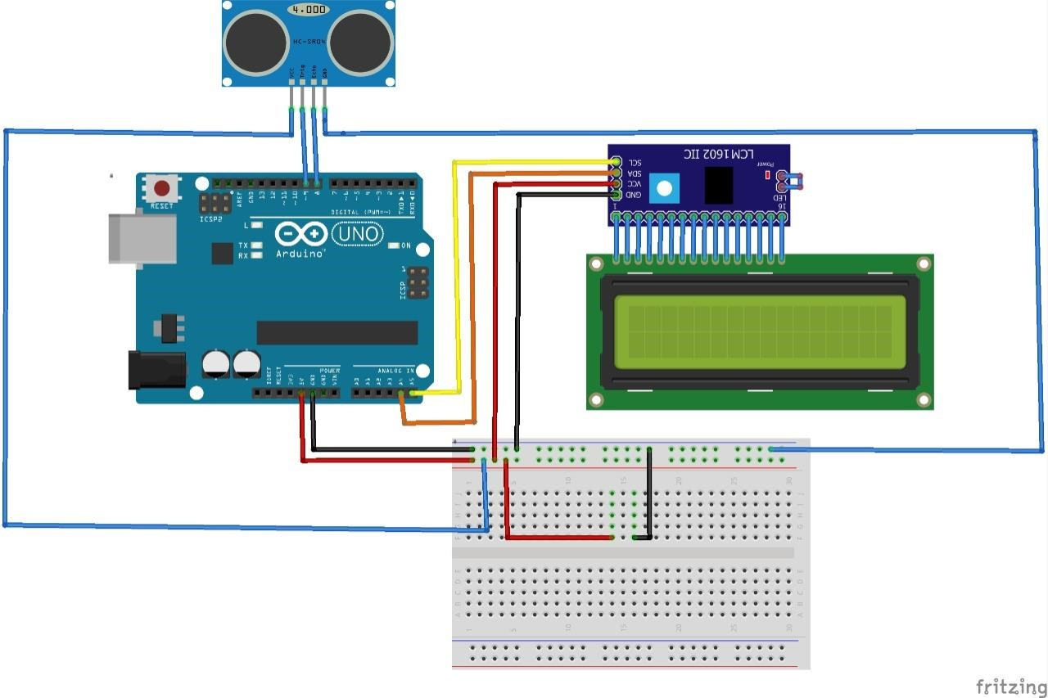

***For This Code Scan The QR Code***